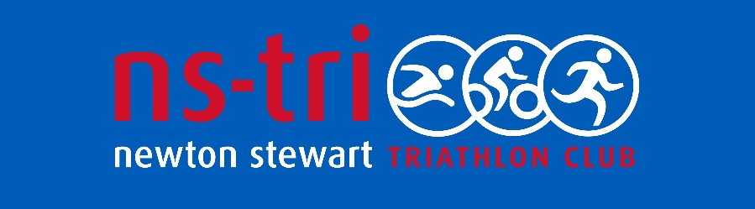

DISCLAIMER AND ASSUMPTION OF RISK

While triathlon is a recreational sport, there are inherent risks and dangers. All athlete/members/training partners are responsible for their own safety during group rides or training sessions, and assume any and all risks of injury, harm, medical conditions, or property damage. Triathletes are urged to wear protective gear (including helmets) and ride/train with caution and respect for others. Newton Stewart Triathlon Club makes no representations or guarantees of any kind relating to safety for training or triathlon events. By participating in triathlons/training, each athlete (on behalf of him/herself and his/her family and heirs) voluntarily accepts any and all risks, assumes all liabilities, and waives and releases any and all damages against Newton Stewart Triathlon Club, its committee, agents, employees, managers, or members. If you do not so agree, do not participate in triathlons or training sessions.

